Assigment3 Week 10

Asmaa Alzahrani

**A Few Simple Contracts**

**Code:**

pragma solidity ^0.8.0;

contract TheLoneliestContract {

    uint public myUint =1;

    function sub(uint amount) public returns(uint){

        myUint -= amount;

        return myUint;

    }

}

contract Name {

    string public massage;

    constructor (string memory message) {

        massage = message;

    }

}

contract Bank{

    mapping(address=>uint) public account_balance;

    function transfer (uint amount, address acctToTransferTo) external{

        require(account_balance[msg.sender]>=amount);

        account_balance[msg.sender] -= amount;

        account_balance[acctToTransferTo] += amount;

    }

    function bankBalance() external view returns(uint){return address(this).balance;}

    function withdrawl(uint amount) external {

        require (account_balance[msg.sender]>=amount);

        account_balance[msg.sender] -= amount;

        payable(msg.sender).transfer(amount);

    }

    receive () external payable {

        account_balance[msg.sender] += msg.value;

    }

}

**Deploy empty contract:**

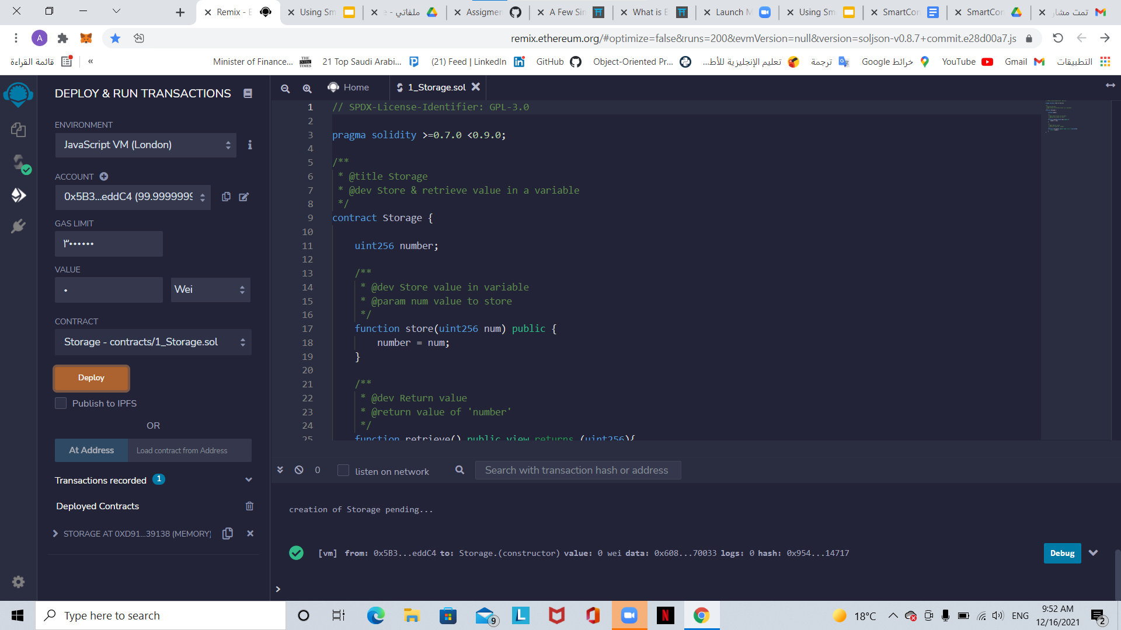

**Test:**

